Database Design -

One to Many Relationships

Step 1 :- understanding definition

One record in one table is mapped to multiple records in different tables

Step 2 :- write a sentence

Eg :- “Store the customer information and the orders that they have made”

Step 3 :- write down the objects from the sentence

Eg :- ( customer information , orders)

Step 4 :- Determine is it a One to Many relationship

Ask yourself - Does obj1 have many obj2s , or obj2 have many obj1s

Eg :- “ does a customer have many orders or does an order have many customers?”

Step 5 :- Draw Entity Relation Diagram of tables



Step 6 :- Draw line between the tables

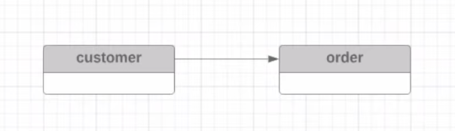

Step 7 :- draw the one-to-many specification between the tables to under the flow

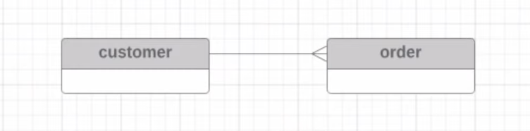

Many to Many relationship ➖

Many records in one table relates to many records in another table

Eg :- multiple students enrolling in multiple classes

Wrong implementation -

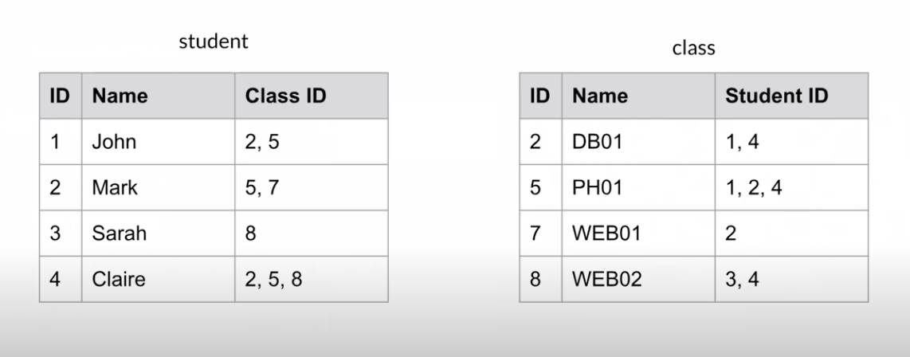

Good practice -

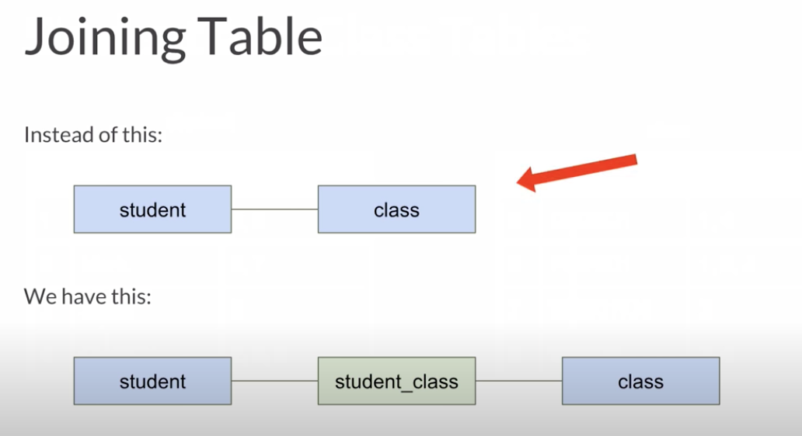

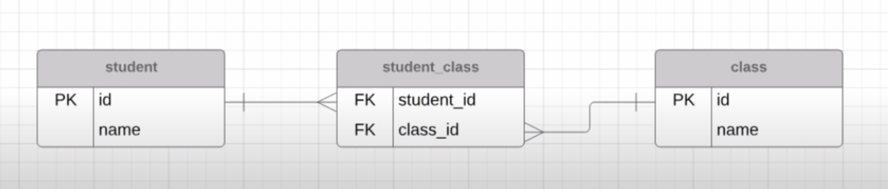

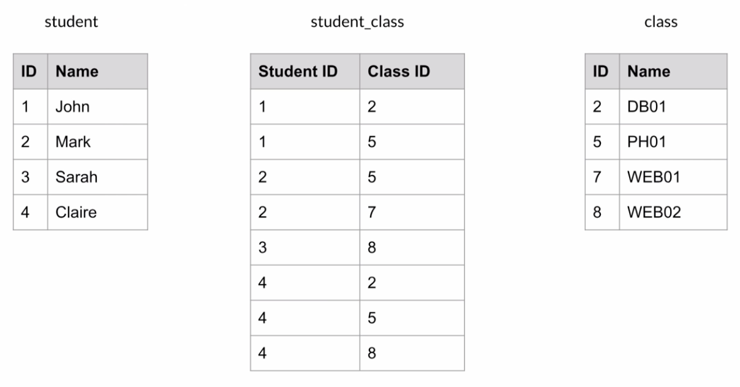

Joins ➖

Get data from multiple tables

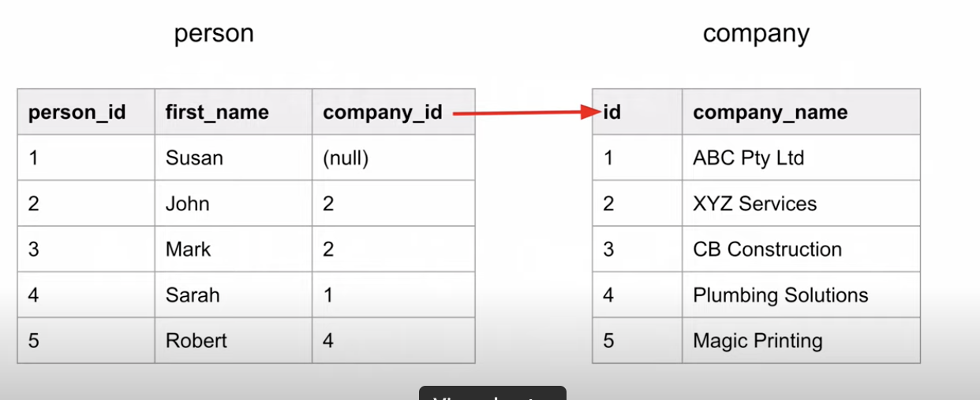

Types ➖

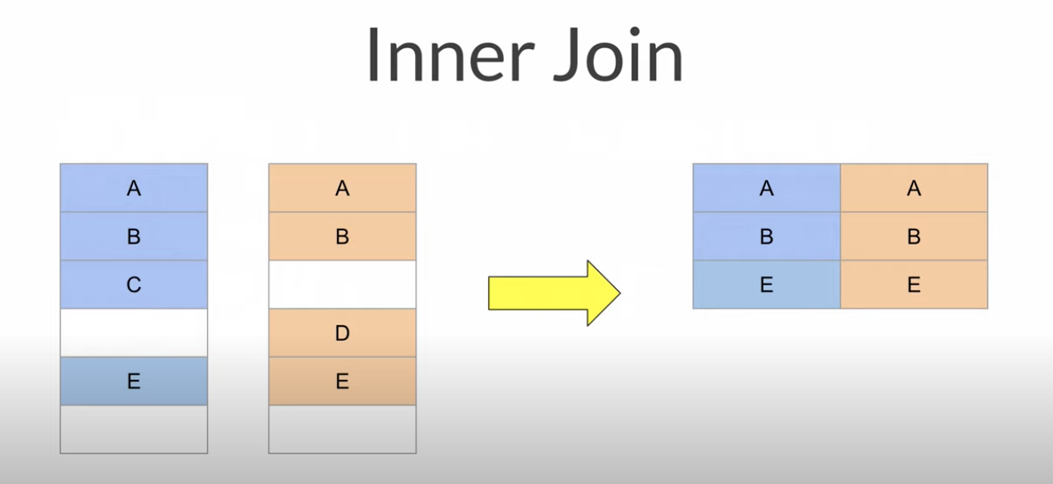

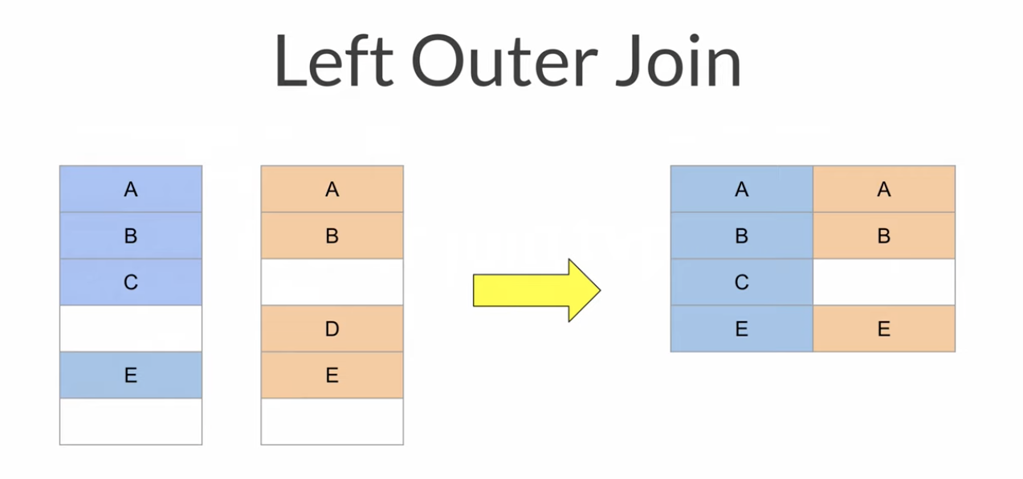

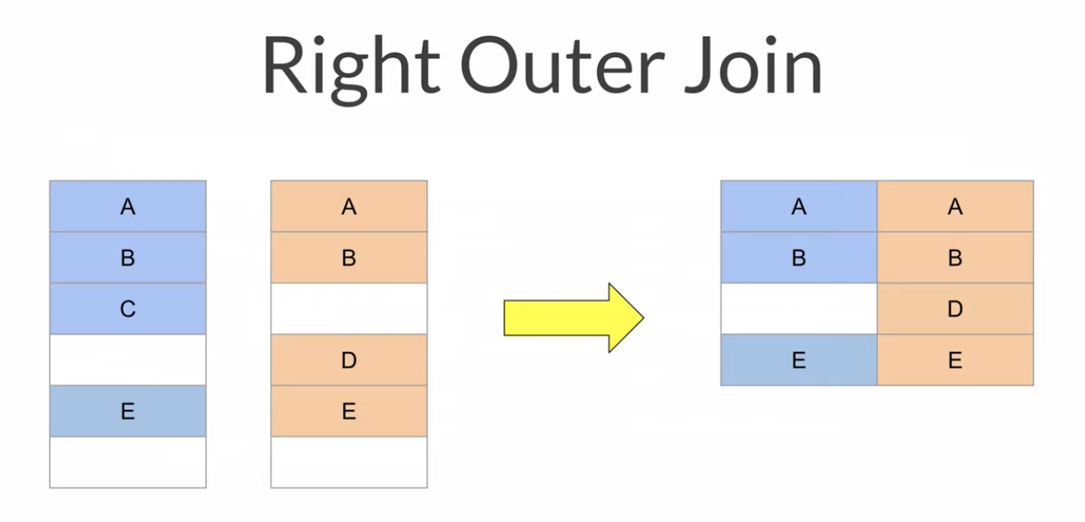

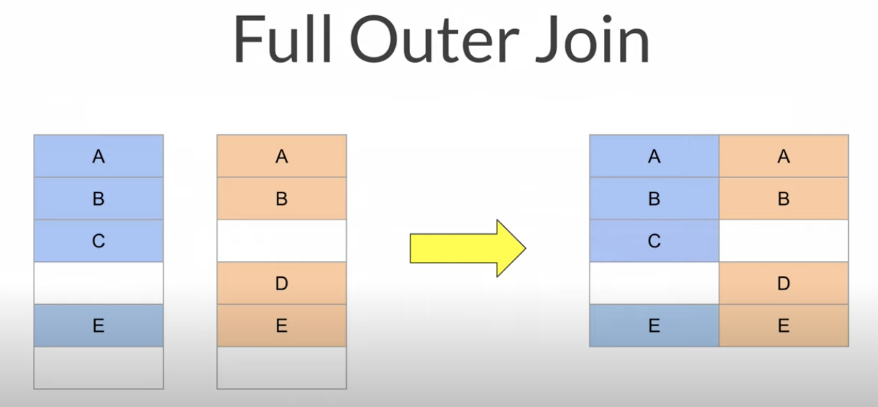

Self join ➖

Joining a table to itself

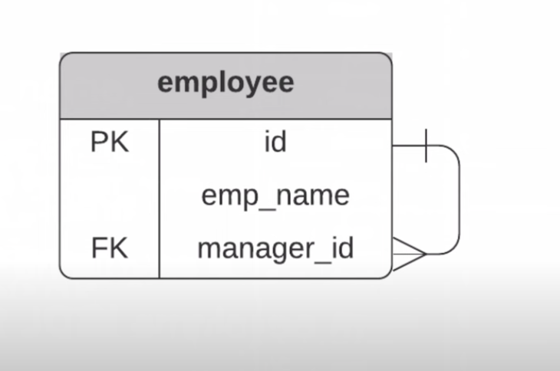

Custom Fields ➖

Possible solutions :-

Solution one : Entity Attribute Value

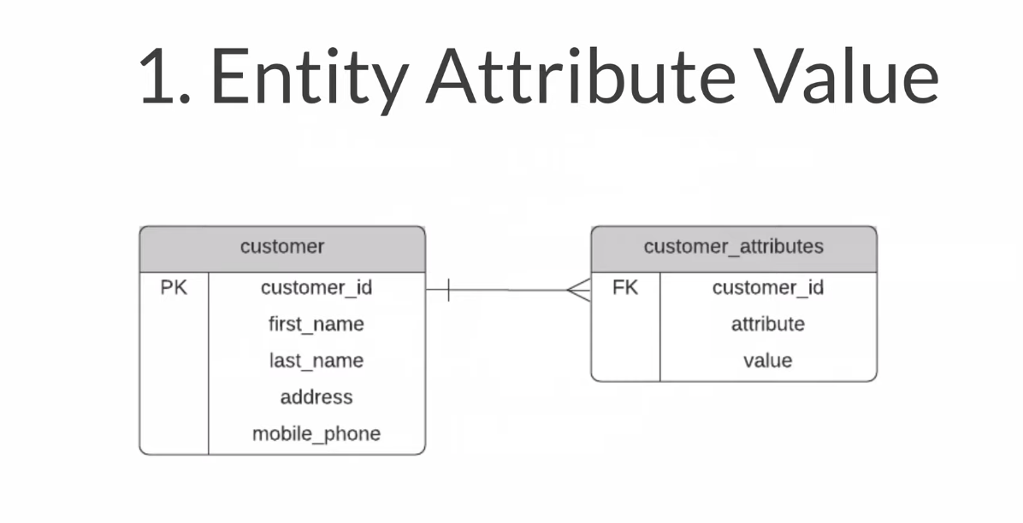

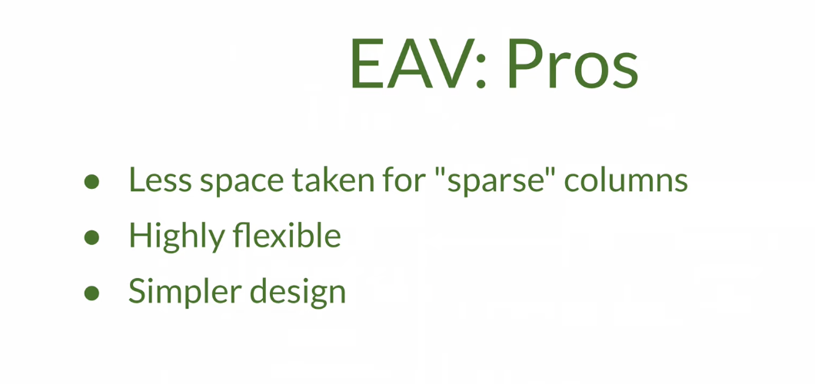

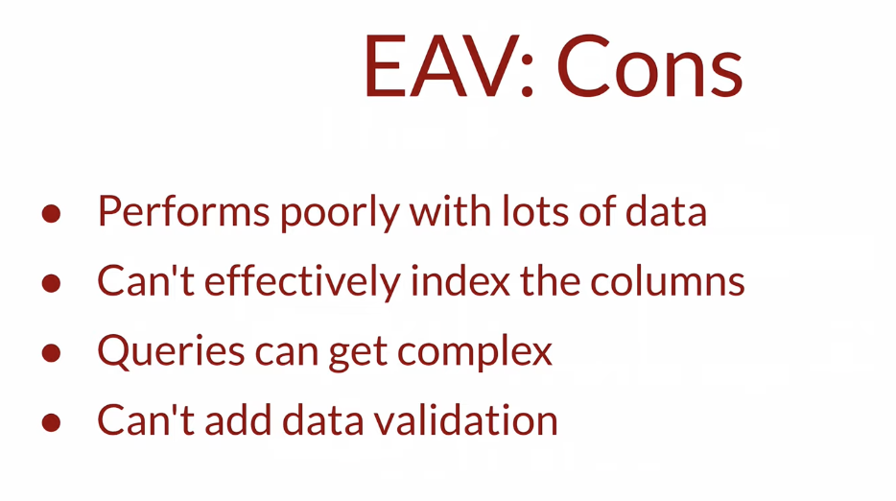

Solution two : Modified Entity Attribute Value

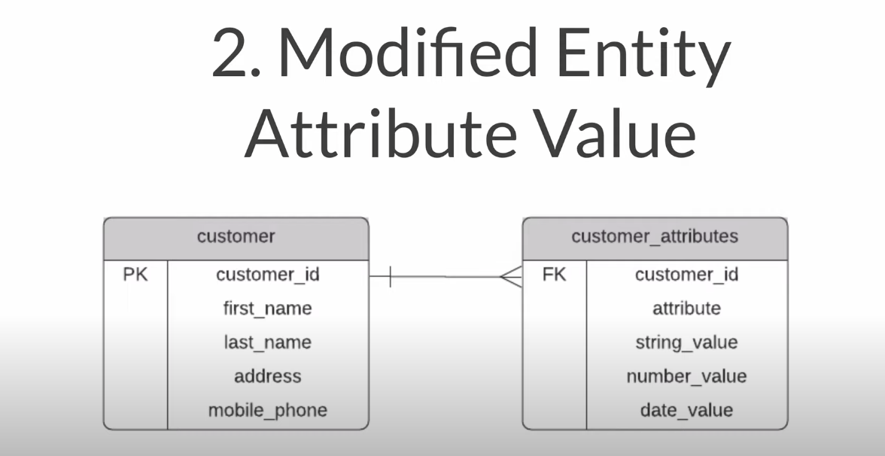



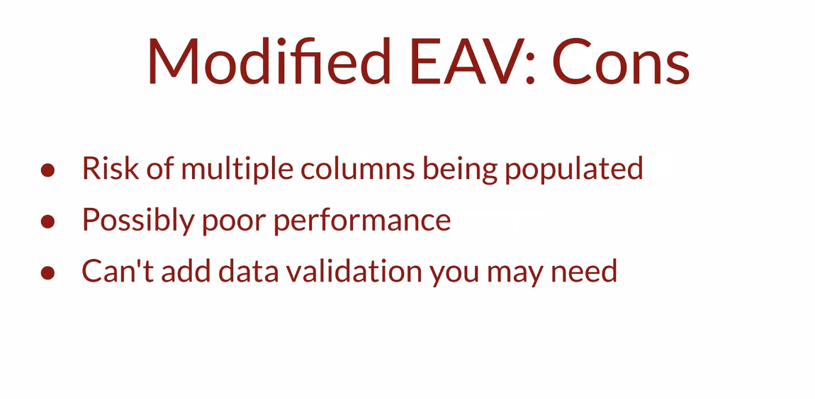

Solution 3 : Single Table

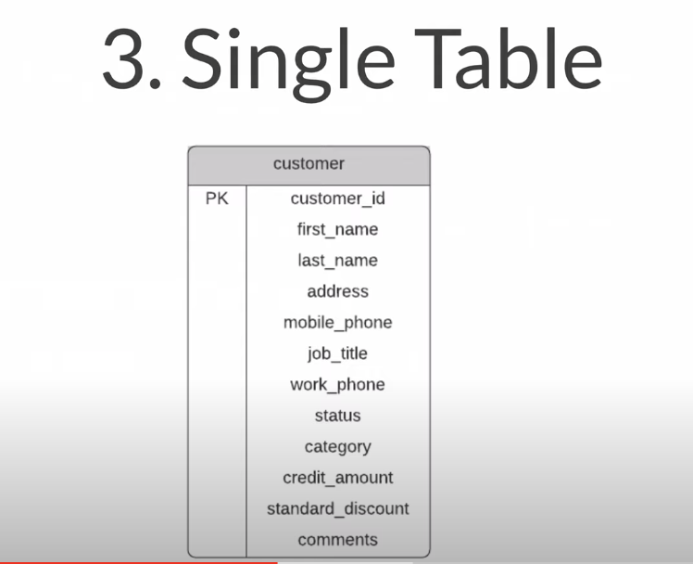



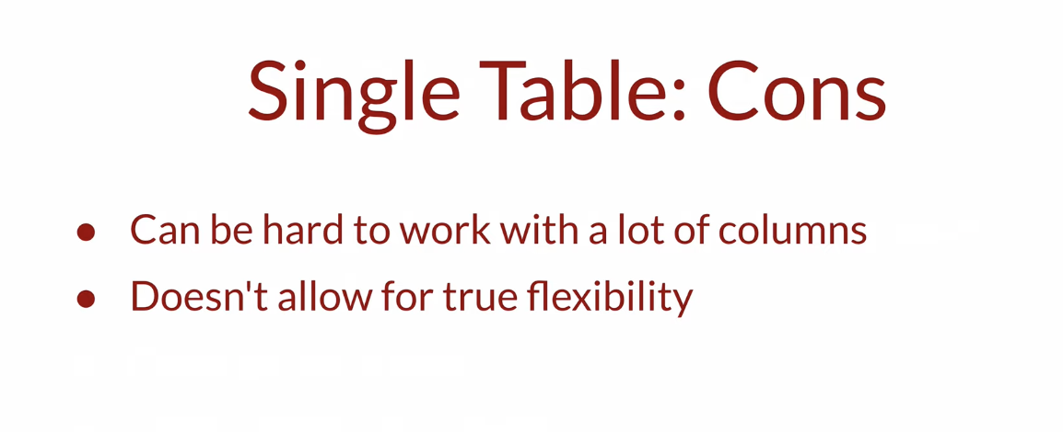

Solution 4 : class table Inheritance

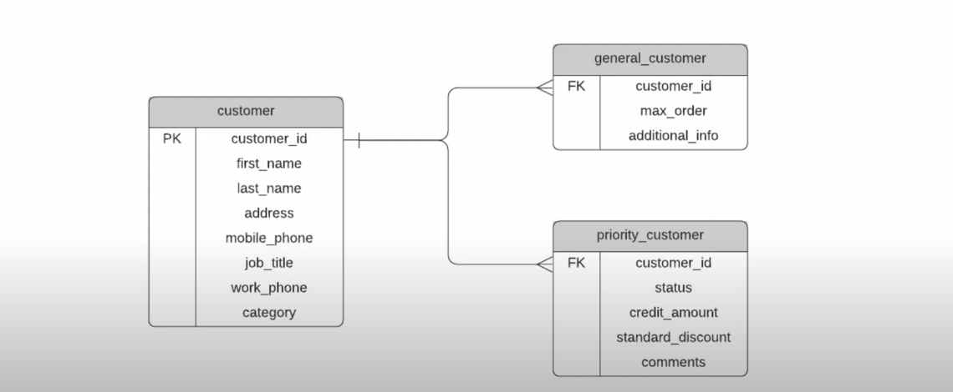

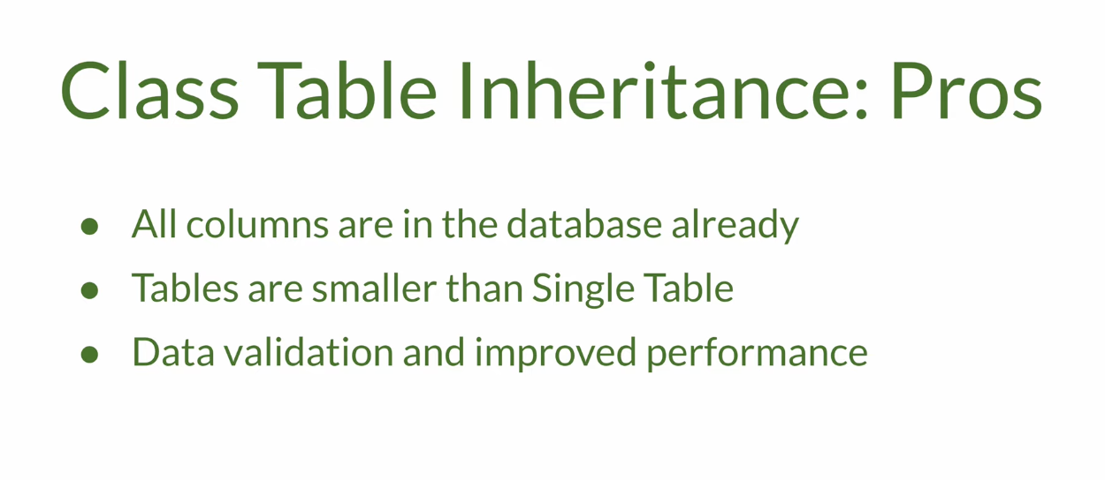

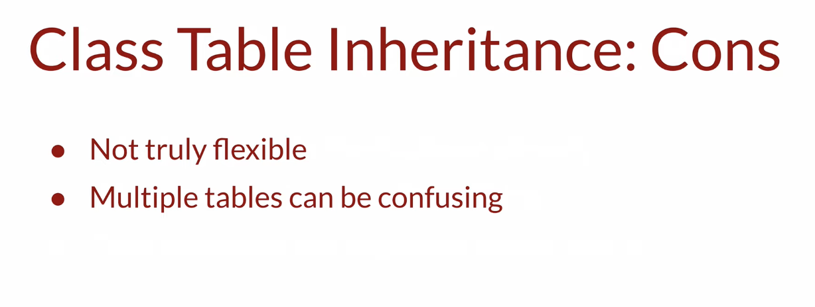

Solution 5 : Concrete table inheritance

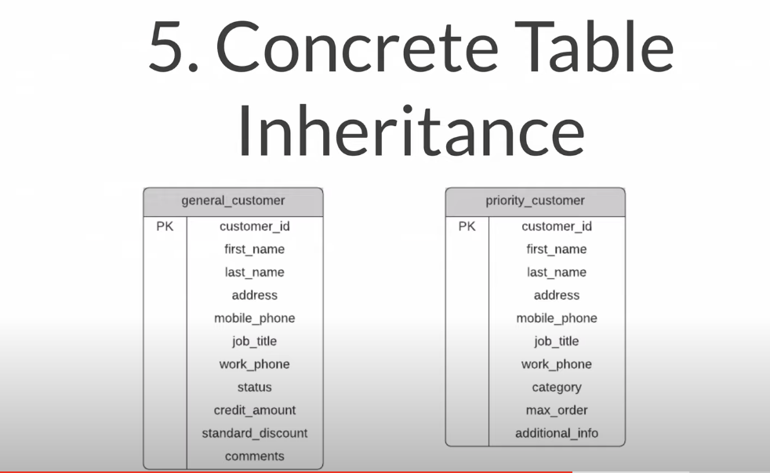



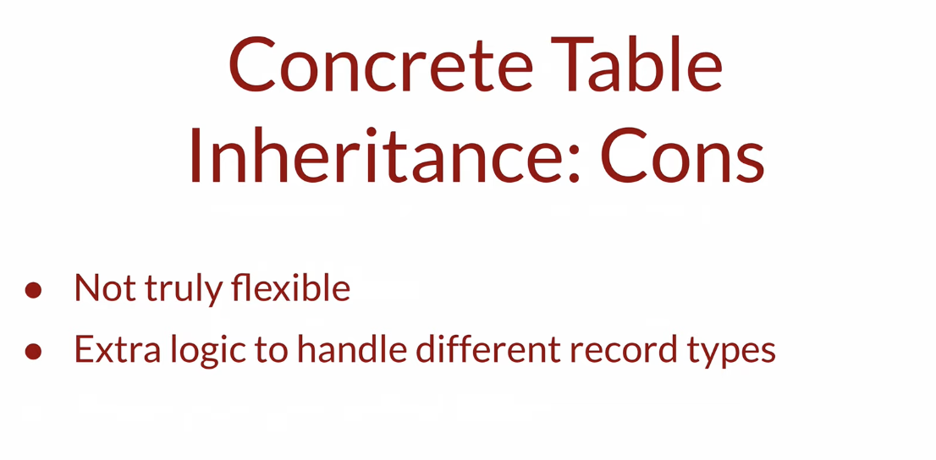

Solution 6 : Normalised Tables

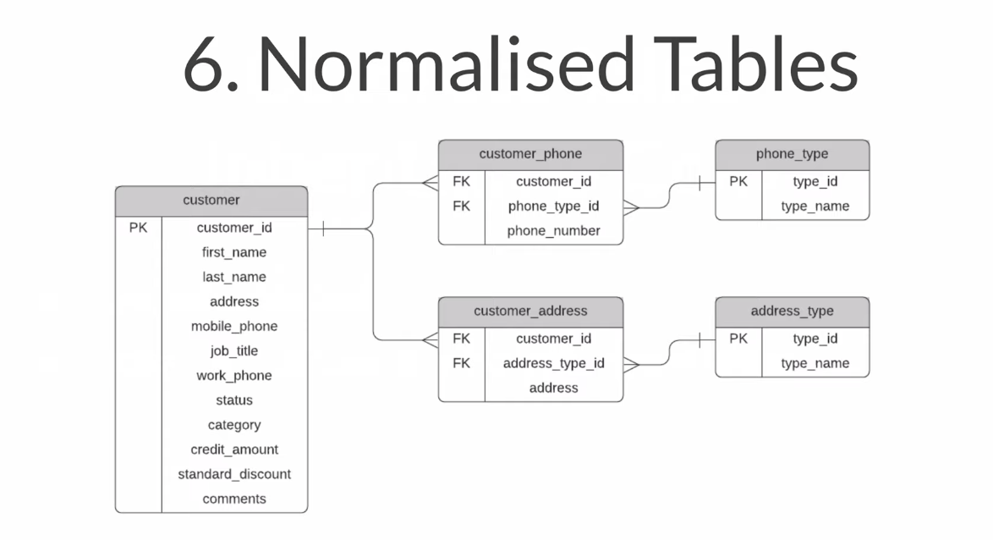

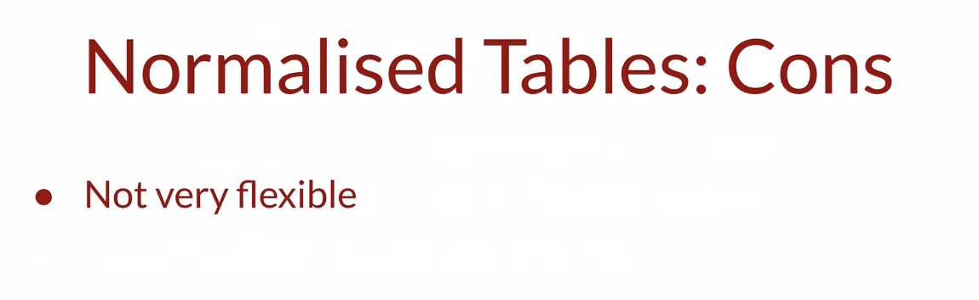

Solution 7 : JSON

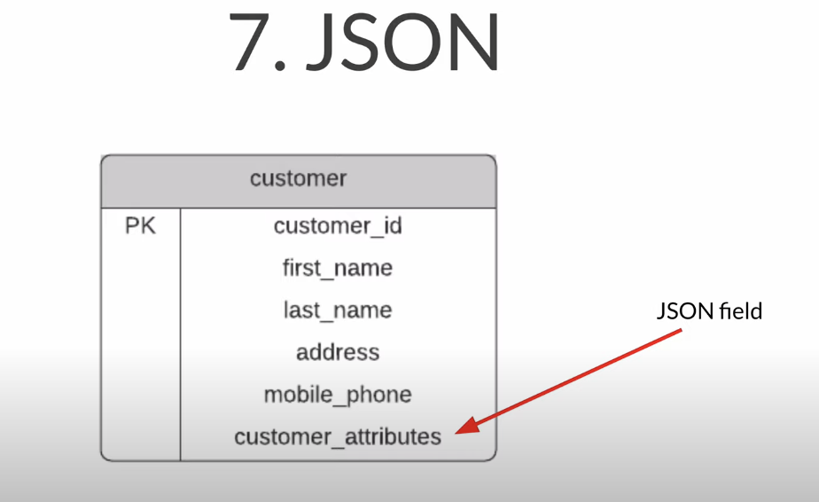





Solution 8 : Dynamic Schema

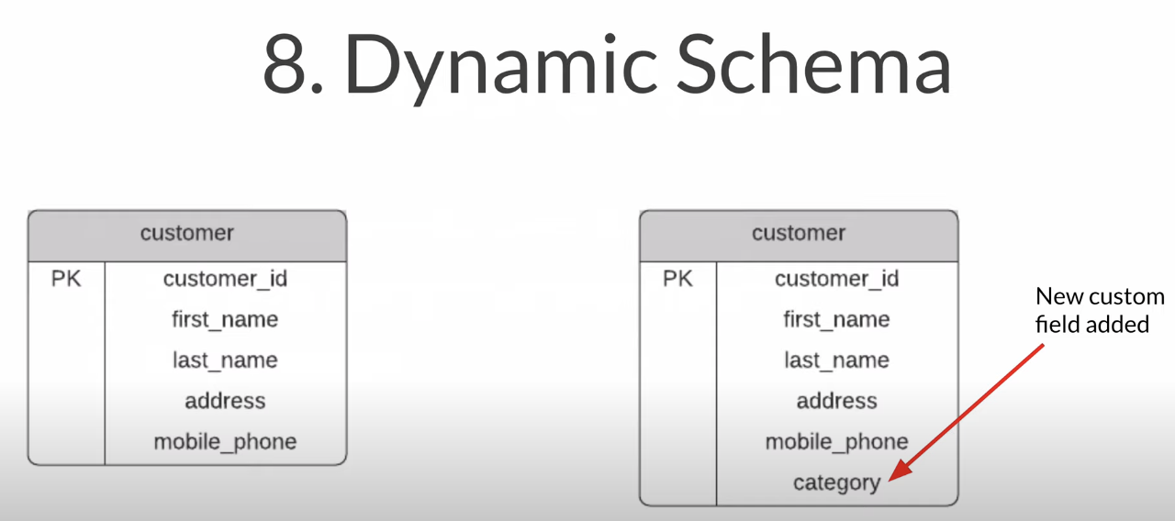



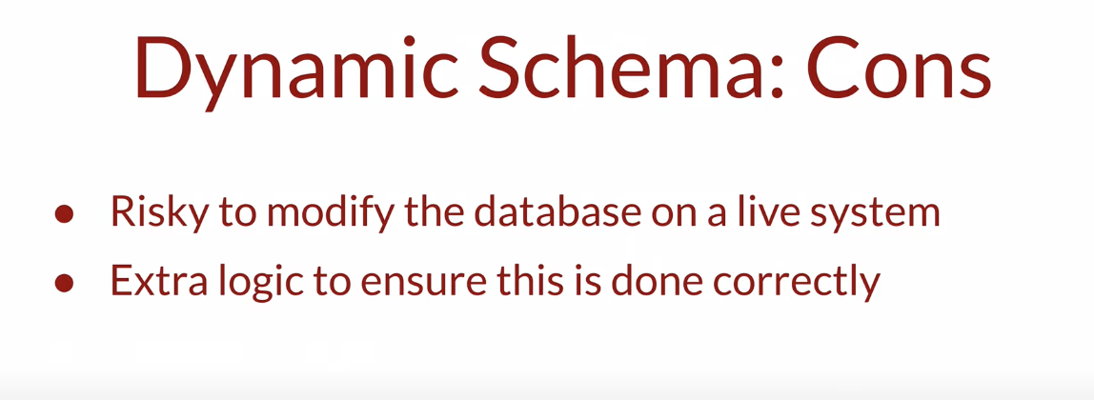

Design mistakes to avoid -

1) Business related field as primary key

Reason:-

* The value can change
* You don’t have control over this field

Solution ➖

* Create new primary key

2) storing redundant data -> unwanted data that dont need to be stored

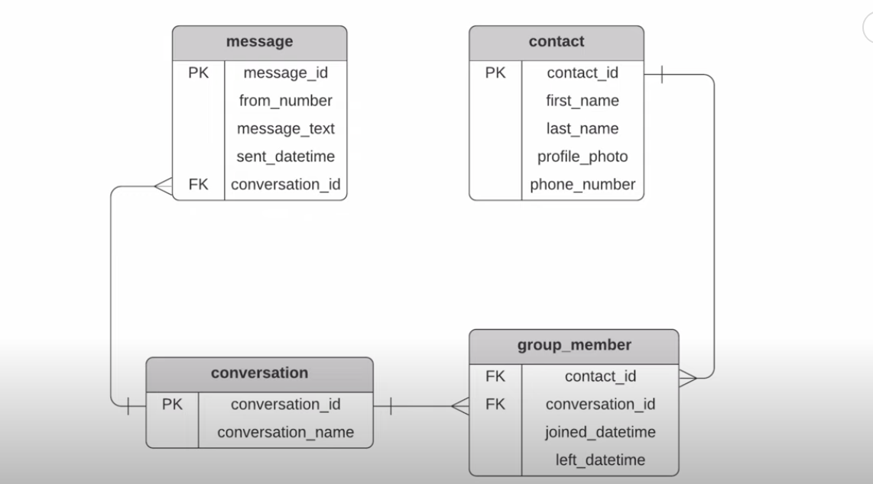

Solution ➖

* Let the application handle the calculation

3) spaces and quotes in table names

Solution -

* Use snake case, camel case or pascal case

4) poor or no referential integrity

Referential integrity :- Data in your database is high-quality

Solution -

Use constraints (primary key , foreign key , unique , not null)

5) multiple pieces of information in a single field

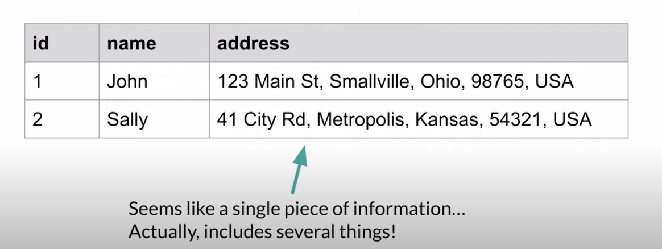

Solution -

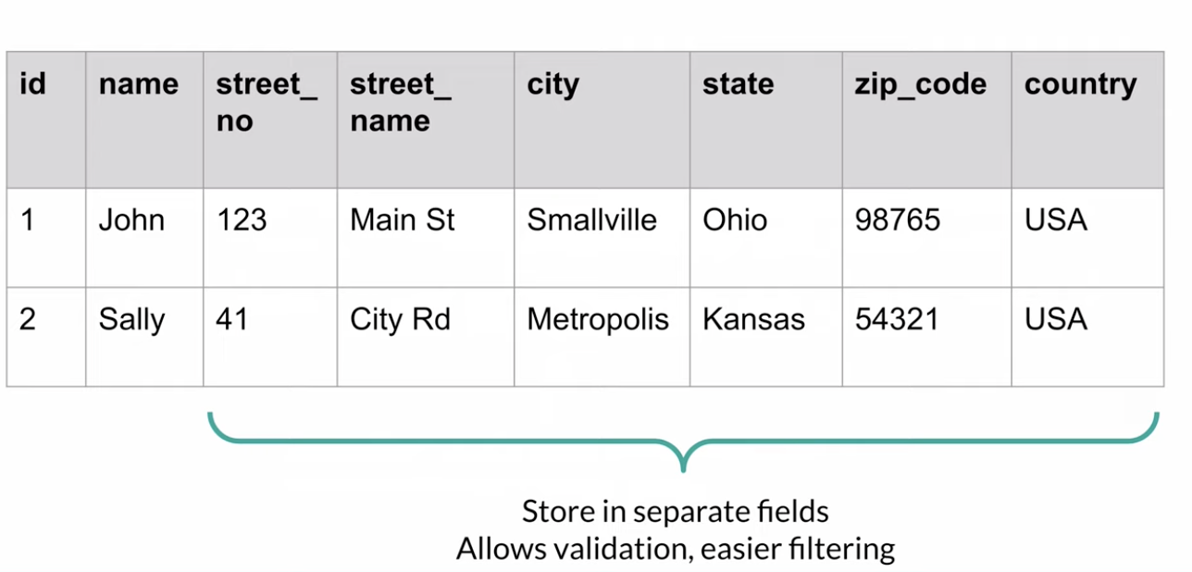

6) storing optional types of data in different Columns

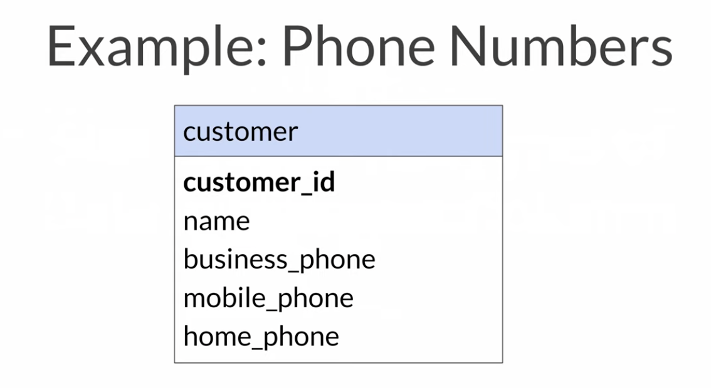

Solution:-

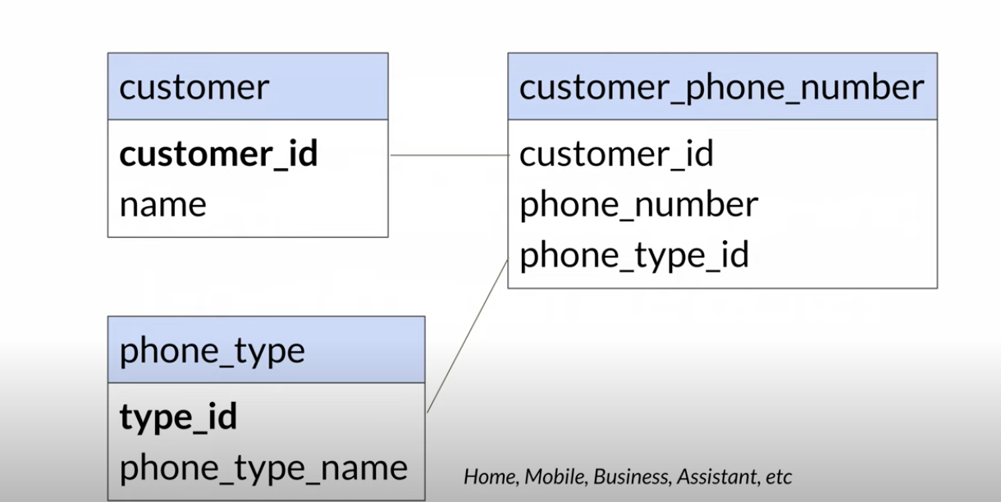

7) using the wrong data types and sizes

Example -

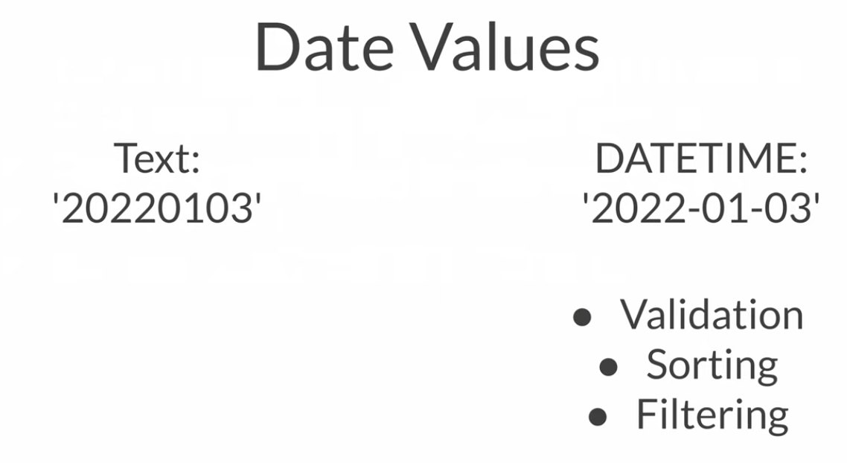



Better way to store mobile number ➖( string ) not number

Database Normalization ➖

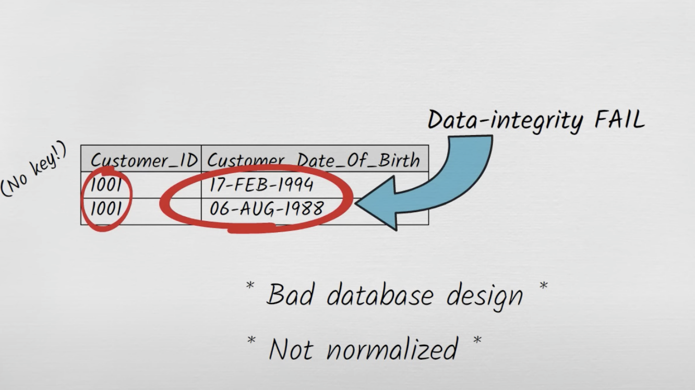

The Normal Forms ➖

First , Second , Third , Fourth , Fifth

First Normal Form ➖

* Using row order to convey info violates 1NF
* Mixing data types within the same column violates 1NF
* A table without a primary key violates INF
* Storing a repeating group of data items on a single row violates 1NF

Second Normal Form ➖

* Deletion anomaly, Updation anomaly, Insertion anomaly
* Each non-key attribute must depend on the entire primary key

Third Normal Form ➖

* Every attribute in a table should depend on only primary key not non-keys

Fourth Normal Form ➖

* Multivalued dependencies in a table must be multivalued dependencies on the key

Fifth Normal Form ➖

* The tables ( which must be in 4NF) cannot be describable as the logical result of joining some other tables together

Database Design : Product Attributes

“ How do we design a product table, where the product can have multiple colours and sizes”

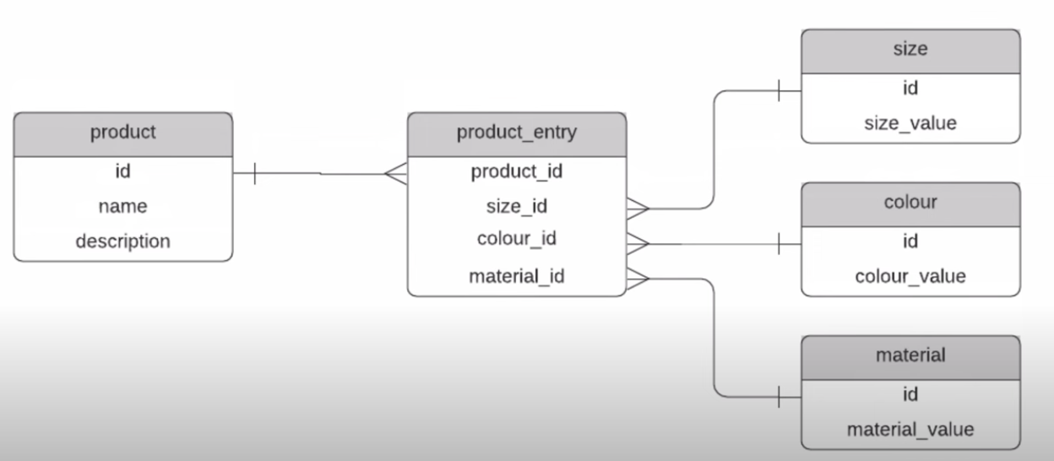

Database Design : Chat Application

Requirements -

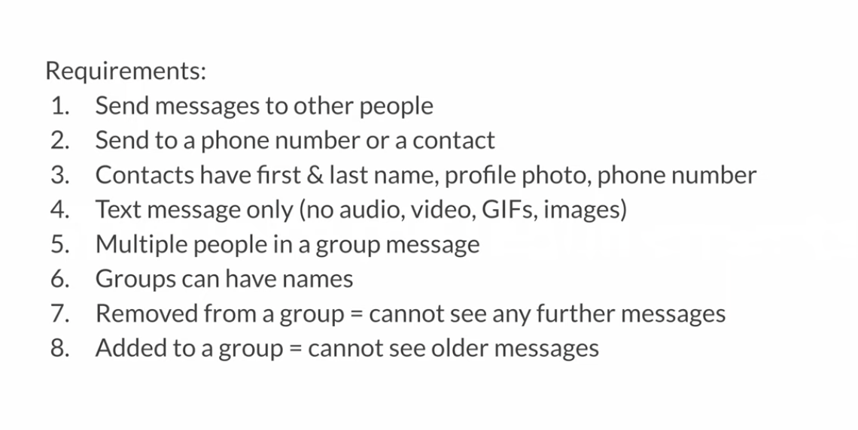

Design -

